Chapter 26 Exercises: R-26.5,



Sol：

To solve this linear program using the simplex method, we first we rewrite the linear

program in slack form, introducing the slack variables, x3, x4.

Maximize: z = x1 + x2

Subject to: x3= 77 – 3 x1 – 5 x2

x4 =56 – 7 x1 – 2x2

x3, x4 0.

We then choose to increase x1. The most restrictive constraint is given by x4，so we pivot x4 and x1, yielding the following new slack form with objective value , c\*= 8.

Maximize: z = 8 + 5/7 x2 - x4

Subject to: x3= 53 - 29/7 x2 + 3/7 x4

X1 = 8 – 2/7 x2 – 1/7 x4

Next we increase x2, as it has the largest coefficient in the objective function . So we pivot x3 and x2, yielding the following new slack form with objective value , c\*= 17.14.

Maximize: z = 17.14 – 0.93 x4 – 0.17x3

Subject to: x2= 12.8 + 0.103 x4 – 0.241 x3

X1 = 4.34 + 0.1034 x3 – 0.172 x4

for all the coefficients of the objective function are negative. we see that the

optimal value for this linear program is 17.14, with x1 = 12.8 and x2 = 4.34.

R-26.7 ( and solve using Simplex Method),

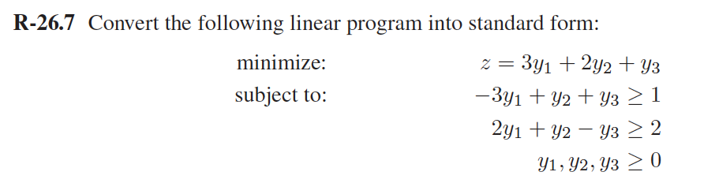

Sol：

First, we transform the equation into standard form like below:

Maximize: z = -3y1 - 2y2 - y3

Subject to: 3y1 - y2 - y3 ≤ -1

-2y1 - y2 + y3 ≤ -2

y1, y2, y3 0.

To solve it, We first transfer the dual form to the primary form, yielding the following new primary form with objective value：

Maximize: z = x1 + 2x2

Subject to: −3x1 + 2x2 ≤ 3

x1 + x2 ≤ 2

x1 - x2 ≤ 1

x1, x2 0.

To solve this linear program using the simplex method, we first we rewrite the linear

program in slack form, introducing the slack variables, x3, x4,x5

Maximize: z = x1 + 2x2

Subject to: x3 = 3 + 3x1 - 2x2

x4 = 2 - x1 - x2

x5 = 1 - x1 + x2

x1, x2,x3, x4,x5,0.

We then choose to increase x2, as it has the largest coefficient in the objective

function. The most restrictive constraint is given by x3，so we pivot x3 and x2, yielding the following new slack form with objective value , c\*= 3.

Maximize: z = 4x1 - x3 + 3

Subject to: x2 = 3/2 + 3/2 x1 – 1/2 x3

x4 = 1/2 – 5/2 x1 + 1/2 x3

x5 = 5/2 + 1/2 x1 - 1/2 x3

Next we increase x1, as it has the largest coefficient in the objective function . So we pivot x1 and x4, yielding the following new slack form with objective value , c\*= 19/5.

Maximize: z = 19/5 – 1/5 x3 – 8/5 x4

Subject to: x2 =9/5 - 1/5 x3 – 3/5 x4

x1= 1/5 + 1/5 x3 - 2/5 x4

x5 = 13/5 - 2/5 x3 - 1/5 x4

for all the coefficients of the objective function are negative. we see that the

optimal value for this linear program is 19/5, with x1 = 1/5 and x2 = 9/5.

R-26-9.

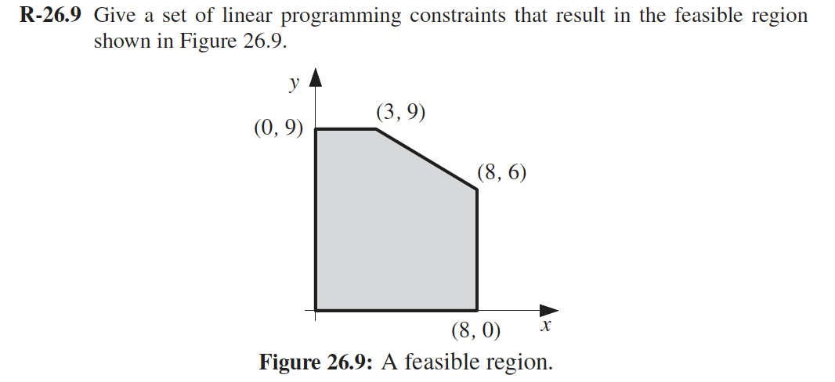

Sol：

By observing the figure, we can get the following constraints :

0≤y ≤ 9

0≤x ≤ 8

for the slope with point (3,9) and (8,6) ,we can get the equation is

y-y1=m(x-x1)

m=(3-8)/(9-6)= -3/5

y-3=-3/5(x-9), therefore 5y+3x ≤ 54

so, the final constraints will be :

0≤y ≤ 9

0≤x ≤ 8

5y+3x ≤ 54